Steps to setup MySQL database and link it to the source code (main.py)
- Download XAMPP and MySQL Workbench
- Start MySQL 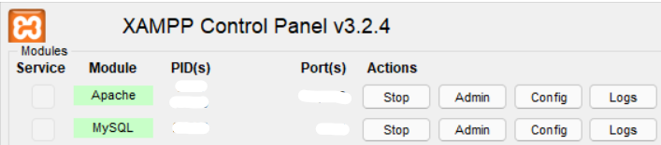
- Create 3 tables on MySQL Workbench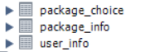
- Set names/price/description on Workbench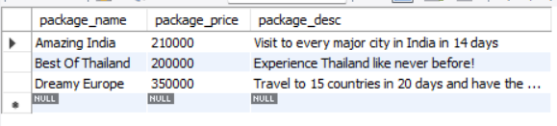

-Reyansh Gupta
Github.com/reyanshgupta

